“The pilot reported a burning smell in the cabin," says this submitter. "An inspection revealed the taxi light circuit breaker switch had an unusual feel. Following replacement of the switch, after disassembling the failed switch, we found burned internal components. This switch (P/N 35-380132-105) is the improved model required by AD2008-13-07, which was modified to prevent the burning situation in the failure mode.

We installed two insulator pads at the actuator spring to prevent the current from flowing through the spring when the wire braid fails. Unfortunately, when these switches overheat, it is difficult-to- impossible to determine if the insulators were improperly installed or installed at all. This is the second post AD switch in our fleet that has failed and overheated." *(Switch manufacturer's name: Tyco. Aircraft total time: 8,059 hours.)*

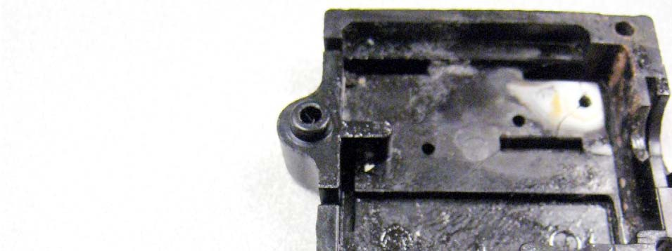

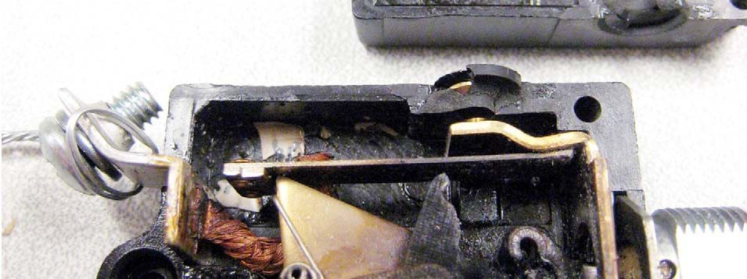

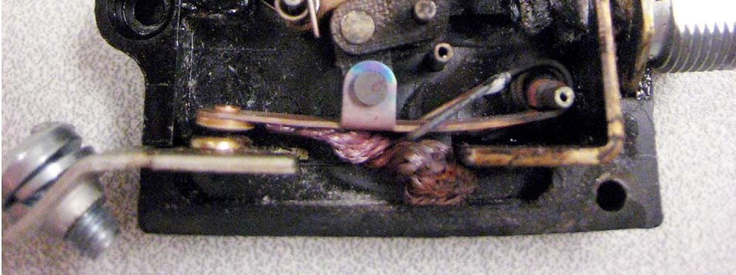

Part Total Time: (Unknown)

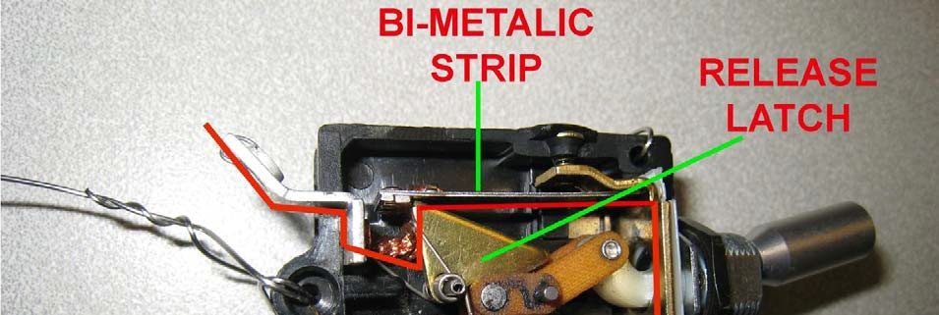

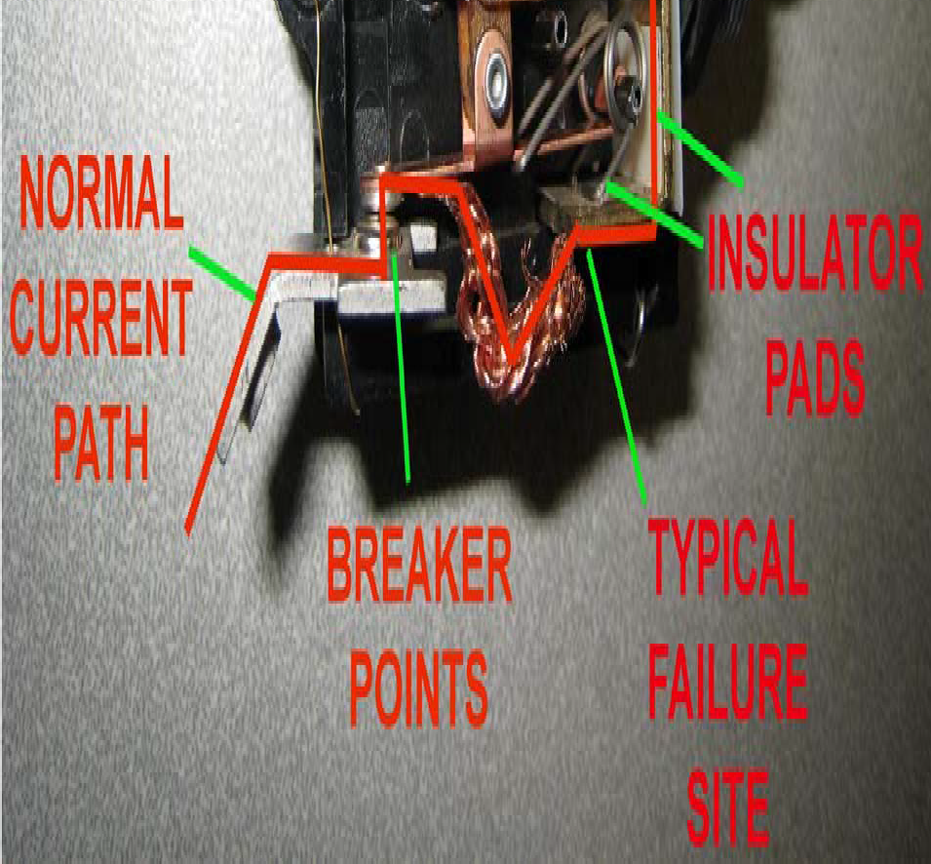

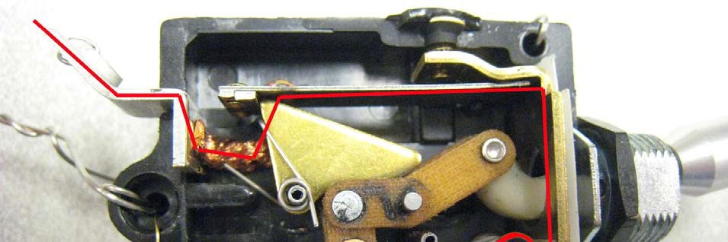

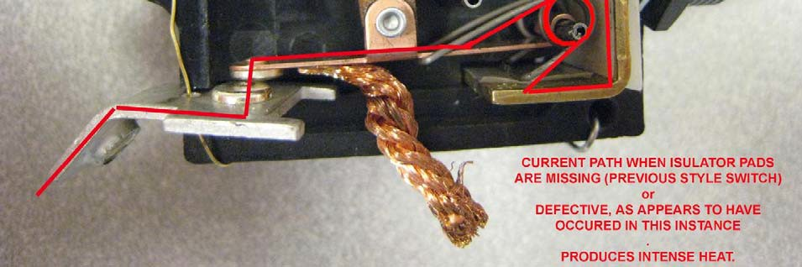

Part Total Time: Unknown